Python Document

## Introduction:

Python documentation serves as a comprehensive guide to leveraging Python data analysis techniques to address the business problem of an increasing bounce rate, which has been identified as a key factor contributing to patient dissatisfaction. This document presents the findings and insights derived from the Python EDA conducted on the pharmaceutical sales data. The analysis aims to provide valuable insights into sales trends, inventory management, and product performance to support informed business decision-making.

Purpose and Scope:

The Python EDA focuses on analyzing the pharmaceutical sales data to uncover trends, patterns, and anomalies. It explores various aspects such as sales trends over time, inventory turnover, product performance, and return rates. The insights derived from the analysis will aid in optimizing sales strategies, improving inventory management, and enhancing overall business performance. The insights presented here will help them gain a deeper understanding of the pharmaceutical sales data and make informed decisions to drive business growth and profitability.

Data Preprocessing:

* Duplicates were identified and removed to ensure data integrity.
* Missing values were addressed using appropriate techniques:
* Imputing common values (mode) for 'Formulation' and 'DrugName' columns.
* Filling missing values in categorical columns with their respective modes.
* Replacing outliers in numerical columns with the median value (to handle potential skewness).

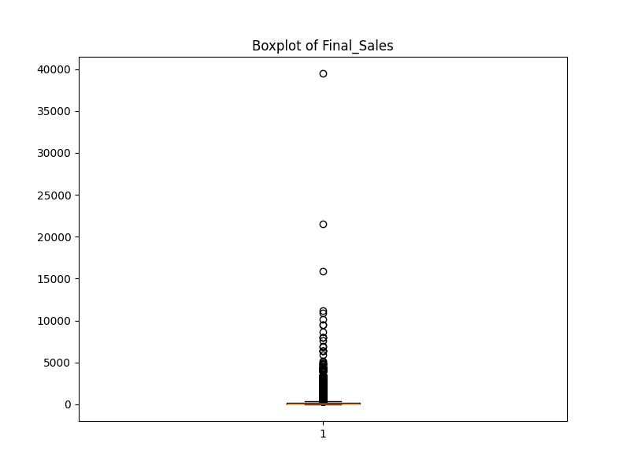

Fig-1 Sales Distribution

This graph shows the spread of final sales for medications in dataset. The center line indicates the typical sale, while the box highlights the range where most sales fall.

Data Analysis:

**Sales and Return Trends:**

Line charts were created to visualize daily sales and return trends over time. This can help identify seasonal variations or promotional effects.

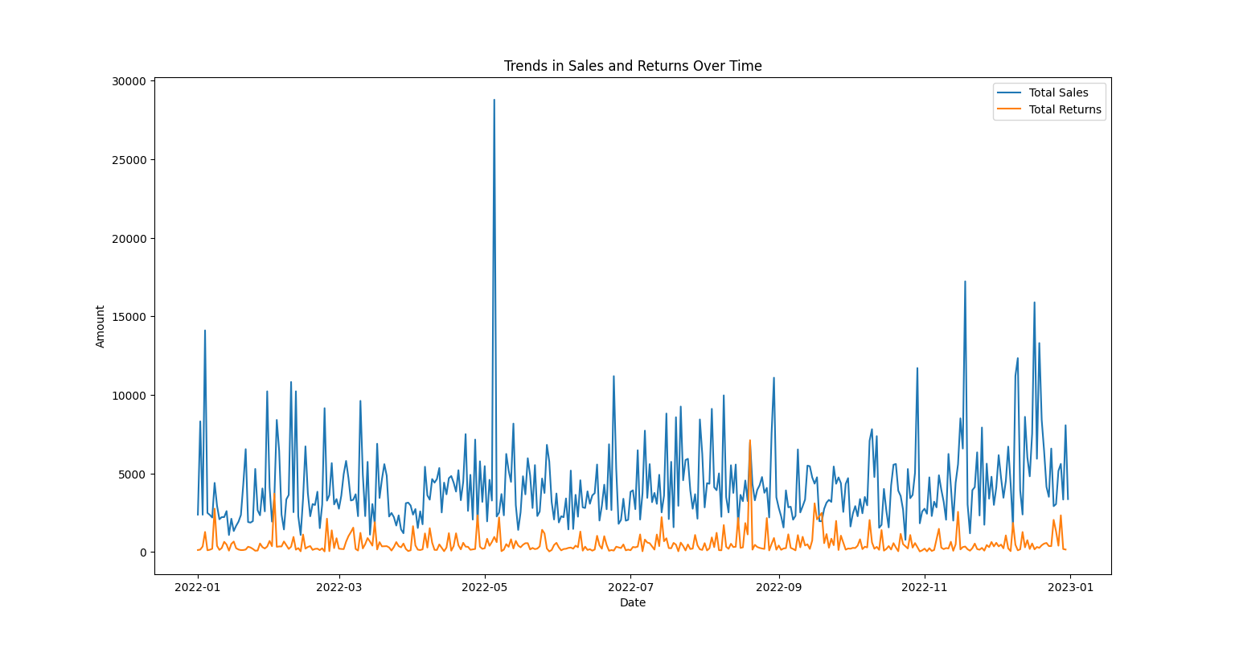

Fig-2 Trends in Sales and Returns Over Time

This line chart depicts trends in sales (blue line) and returns (red line) over time. The x-axis represents the date, and the y-axis represents the total amount.

**Inventory Performance:**

The inventory turnover ratio was calculated to assess inventory efficiency. A higher ratio indicates better inventory management by selling through stock faster. The return rate was also calculated to understand the percentage of medication returned.

In our analysis, the inventory turnover ratio is calculated to be 14192.0, indicating that, on average, the inventory is turned over approximately **14192 times** within the analyzed period.

Our analysis reveals a return rate of 0.1314, indicating that approximately **13.14%** of the products sold are returned by customers.

**Product Analysis:**

The top 10 drugs and top 6 subcategories contributing to the highest sales were identified and displayed using bar charts. This helps prioritize focus on high-performing products.

Return rates were analyzed for individual drugs and subcategories. This can reveal insights into product quality or areas for improvement.

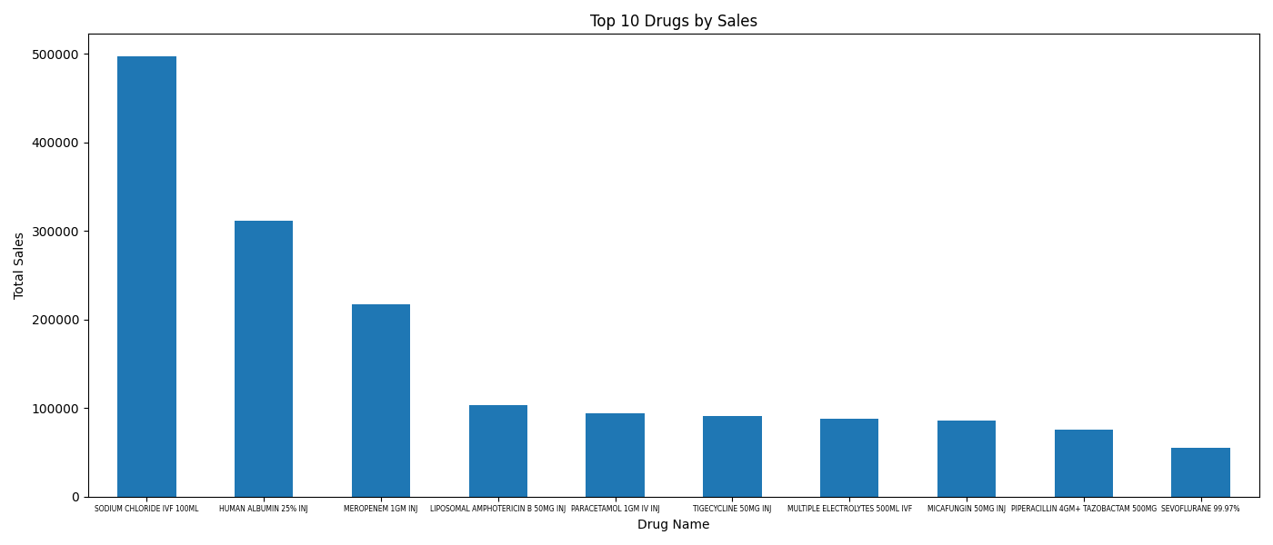

Fig-3 Top 10 Drugs by Sales

This bar chart highlights the ten medications contributing the most to overall sales in data set. The drug names are listed on the x-axis, and their corresponding total sales amount is represented on the y-axis.

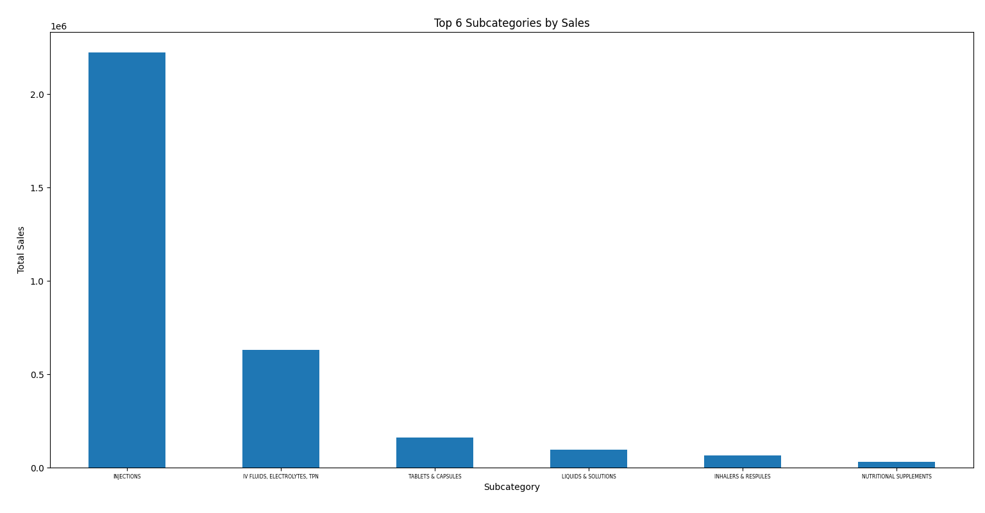

Fig-4 Top 6 Subcategories by Sales

This bar chart highlights the six subcategories of medications contributing the most to overall sales in data set. The subcategories are listed on the x-axis, and their corresponding total sales amount is represented on the y-axis.

Interpretation:

* **Quantity**: Customers typically purchase around 2 units of medication per transaction, indicating a moderate demand.
* **Return Quantity**: Returns are infrequent, with the majority of transactions not involving any returned items, suggesting a low rate of dissatisfaction or product issues.
* **Final Cost**: The average cost of medication per transaction is $124.82, but costs vary significantly, highlighting the need for pricing strategies tailored to different customer segments.
* **Final Sales**: Sales figures are positively skewed, indicating that a few high-value transactions contribute significantly to total sales, which may present opportunities for targeted marketing or upselling.
* **Returned MRP**: Most returned items have a retail price close to zero, indicating that returned products often have little resale value, which may impact profitability and inventory management decisions.

## Recommendations

Provide actionable recommendations based on the analysis

* Monitor inventory levels closely to optimize stock levels.
* Investigate the factors contributing to high return rates and take corrective actions.
* Implement pricing strategies to maximize profitability, considering the variance in final sales.

## Conclusion

In conclusion, the insights gleaned from our SQL documentation present actionable strategies to address the business problem of increasing bounce rates and patient dissatisfaction. By leveraging SQL analysis, we have identified key opportunities to minimize bounce rates while optimizing inventory costs, aligning with our business objectives. we anticipate a tangible improvement in patient experiences and overall business performance. As we move forward, the learnings from this documentation will guide informed decision-making, fostering a culture of continuous improvement and sustainable growth within our organization.